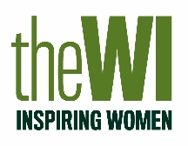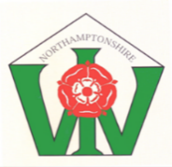

NORTHAMPTONSHIRE COUNTY FEDERATION
OF WIs

PAULINE DUFF TROPHY
2026

AN ITEM OF HEADWEAR

AN ITEM OF HEADWEAR

ENTRY FORM

Name | ……………………………………………… | .
WI | ………………………………………………. | .
Address | ………………………………………………. | .
 | ………………………………………………. | .
 | ………………………………………………. | .
Email | ………………………………………………. | .
Phone | ………………………………………………. | .

Please return this form of intention to submit your entry to
WI House NO LATER THAN Monday, 24th July 2026 with £5 entry fee.

(cheques made payable to NCFWI)
This Photo by Unknown Author is licensed under CC BY-NC
BACS payments also accepted to
a/c 65202746 sort code 08-92-99
account name Northamptonshire County Fed of WI

The 2026 Pauline Duff Trophy is for

An Item of Headwear

- This competition is open to members of Northamptonshire County Federation of WIs only.
- Judging will be in line with WI guidelines.
- The judge’s decision will be final
- Entries must be an original design and made by the person stated on the entry form. You should include a written description of your entry.
- The item must be wearable.
- By submitting an entry, you are giving permission for your item to be photogaphed and the information relating to your entry to be shared on social media and in print.
- All styles of headwear will be given equal consideration.
- There are no size regulations.
- Entries will be displayed at the AGM on Wednesday 21st October 2026 and arrangements must be made for them to be collected at the end of the evening.
- Entry form to be returned to WI House by Monday, 24th July 2026
- Entries to be delivered to WI House for judging no later than Monday, 7th September 2026

Scoring

Points will be awarded for:

Design and use of colours 5 points
Suitability of materials 3 points
Wearability 3 points
Techniques and worksmanship 10 points
Finish and presentation 4 points

Total points available 25 points

The judge’s decision will be final

